Made 4for me

Made 4for me, short 4ME, is an app that revolutionizes social shopping. Some of the biggest social apps there are now; Instagram, TikTok, YouTube, Snapchat and Facebook have tried to get inn some shopping aspect, either through ads or posts. Instagram has its own shopping page, but the user is forwarded to another page, the shopping doesn’t happen within the application. The Made 4for Me app is going to change this, where both the social and the shopping happens within the app.

This is a project where I work as a consultant for a start-up, they had gotten a design proposal, but wanted me to do a redesign, and create an app for today’s 15–25-year old’s that allows them to scroll while keeping up with today’s trends. The project is still under development, and the design is in its final stages before delivery front-end and back-end coders.

This project has challenged me in many ways. I am used to working in groups, but this was a project where I mostly worked alone. I am lucky to know the owners and could ask them for different perspectives when I got stuck in a thought or on an idea. I also created the logo, which is not something I have done during my studies. There was supposed to be a graphic designer who fixed up what I created, but as we all know, plans don’t always go as you want, so the final version is my design. The logo design and the app changed with each other, so when there was a big change in the app or with the colors, there was also an updated version of the logo.

At the beginning of this project, I had a meeting with the start-up to talk about what they liked and what they would like to improve in the design they had from before. We talked about functions, who I was designing for, and their expectations to the final delivery.
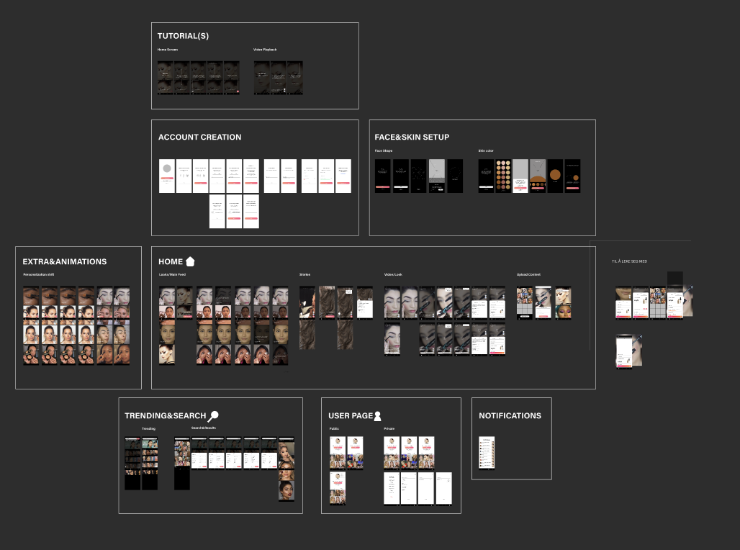

You can test out this version by clicking here: https://www.figma.com/proto/NuzwEXLk8YnLHqhjcV0c5G/Looks---privat-backup?page-id=0%3A1&node-id=1%3A2&viewport=815%2C368%2C0.22&scaling=scale-down&starting-point-node-id=1%3A2

After a chat with a lot of impressions, ideas, and thoughts I started at the very beginning with sketches. This helped me with sorting through what needed to be prototyped, what functions could be placed where. Lucky for me, you don’t have to be an artist to be a designer, you just need the ability to express your thoughts clearly. And if you can’t draw it, you can add some text to it.

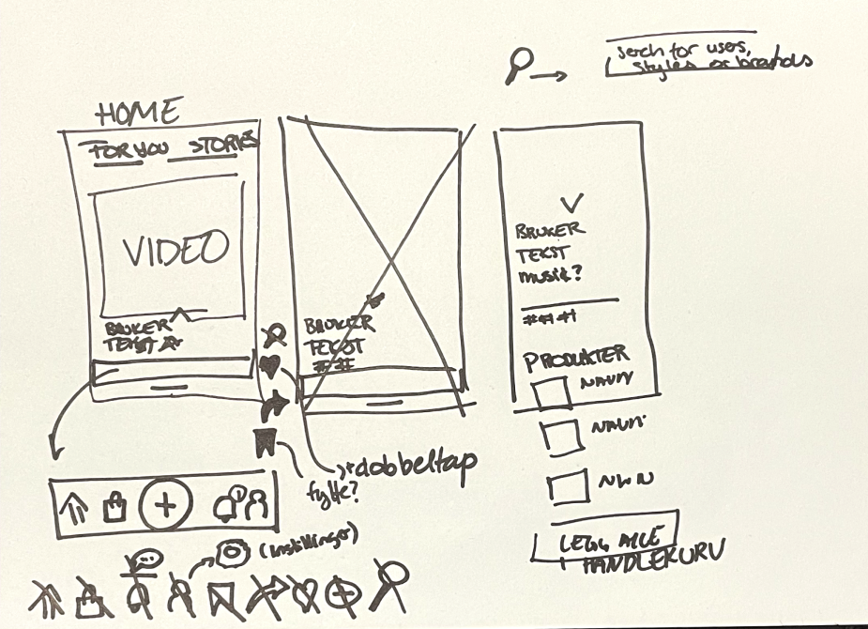

After sorting through the task at hand, I went back to my main contact person, Kristine, to talk with her about the sketches I had made to make sure we were on the same page. During this meeting we also started playing around with the logo and came up with the first drafts.

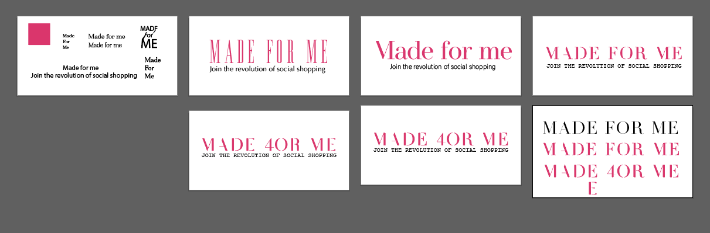

Kristine and I kept working on the logo while I designed the protype and we tested different ways to connect the logo to make a smaller version of it.

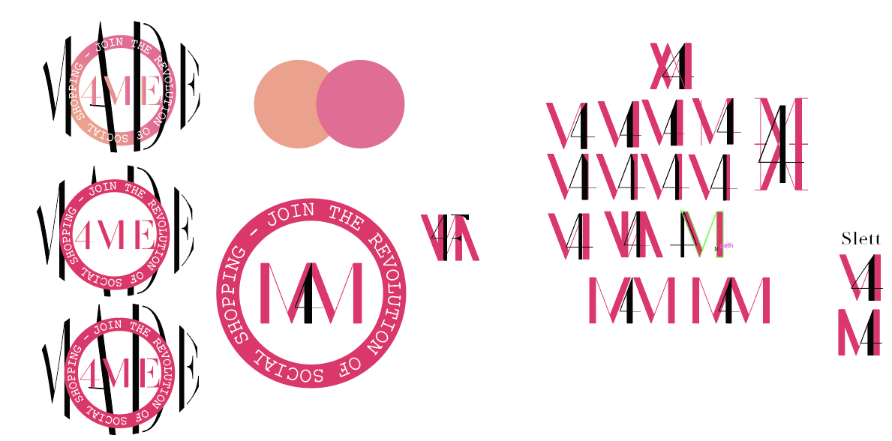

We showed this to the rest of the group and had a logo workshop. The results from the workshop turned into our first “proper” logo proposal and we had new colors for the app.
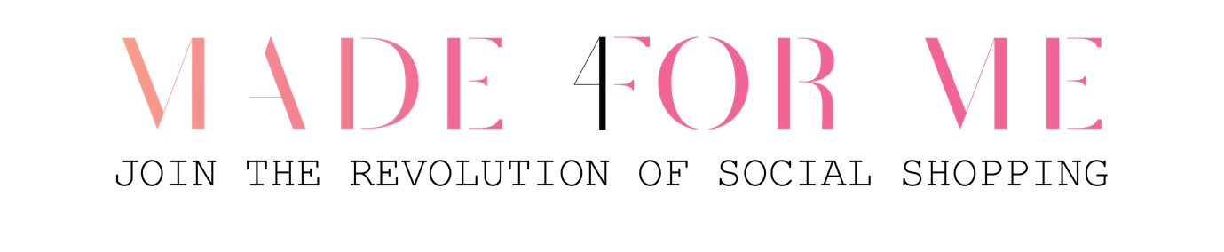
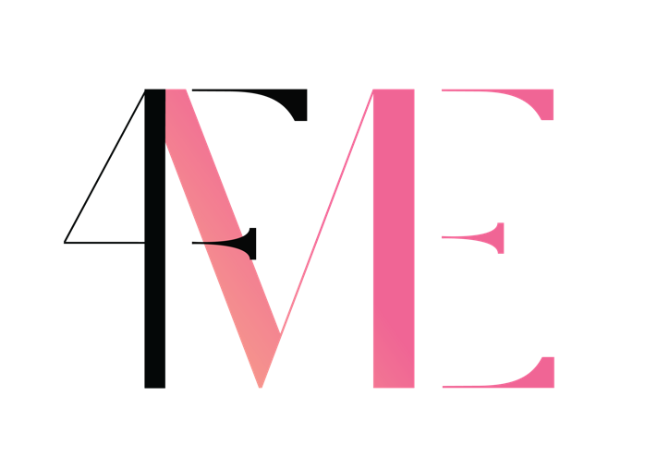

That meant that I also had the main colors for the first prototype in Figma. I did to one mistake that I felt later in the process. As I had a design that was supposed to be remade, I thought I could go straight to redesigning a mid-fi prototype, but I should have followed the normal pattern; low mid hi. In following my process, you will see why.

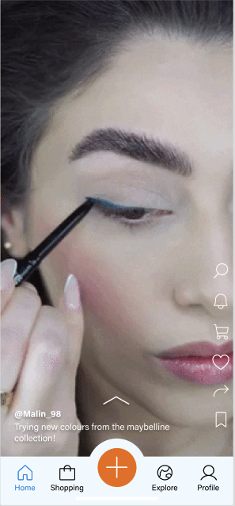

My first design looked like this, you can test the prototype here: https://www.figma.com/proto/NuzwEXLk8YnLHqhjcV0c5G/Looks---privat-backup?page-id=1621%3A515&node-id=1622%3A1218&viewport=222%2C501%2C0.1&scaling=scale-down&starting-point-node-id=1622%3A1218&show-proto-sidebar=1

In this version there was a few problems with contrast, text-side and when it comes to WCAG and UU. But as this was the first version, I didn’t focus so much on that part jet. I needed something to user test and to show the start-up, because I had a feeling that there would come some big changes. The main focus point in the first version was to put in everything the start-up had requested, and find logical places to put everything, and figure out the easiest ways to navigate through the app.

While working in the user testing phase we had to change the colors in the logo, as it was perceived as very feminine, while we wanted to keep it more gender neutral. The results of this were changing the peach color with a blue one.

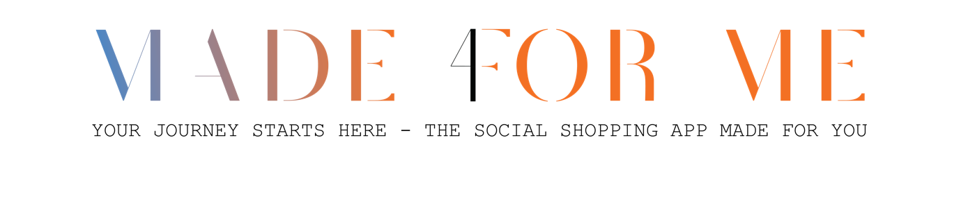
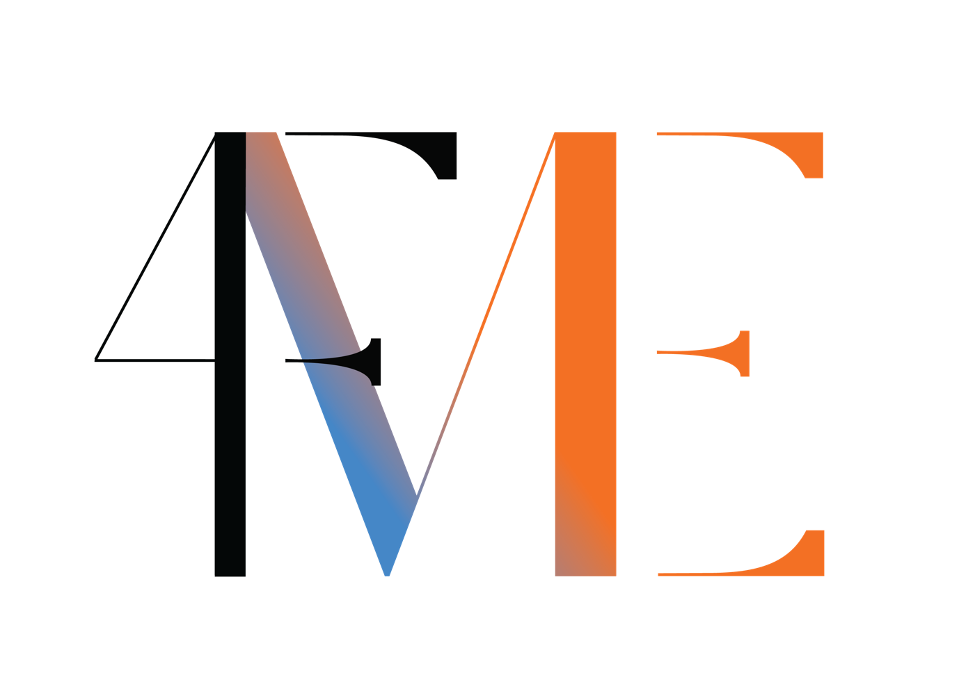
During my user test I tested on collogues and people within the age groups 15-25year old’s. I wanted to run it by my collogues first, because many of these people thought me during my bachelors, and I knew they would have some great tips, tricks and feedback for me. I summed up the feedbacks and the list after 6 tests looked like this:

- Make things bigger
- Scroll to close or go back
- Tap on the video to get more information
- I don’t really understand what all the icons are or where they take me
- Make more of a hierarchy
- I want to go back in the tour
- There is way to much text in the tour, I would never read all this
- Do I really need all these ikons?
- Can it be a bit more color full?
- I feel like I can´t hit the button I want to (make it bigger)
- Biometry: am I making me or an avatar?
- Can I make folders inn my saved videos?
- What is that google icon? (in shopping)

By the time I was done with the user testing, the start-up had once again changed their mind on the color, and I met with Kristine one more time to fix the logo. The last version that I made for them looks like this:

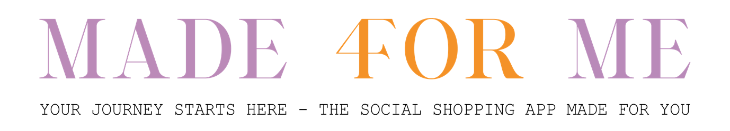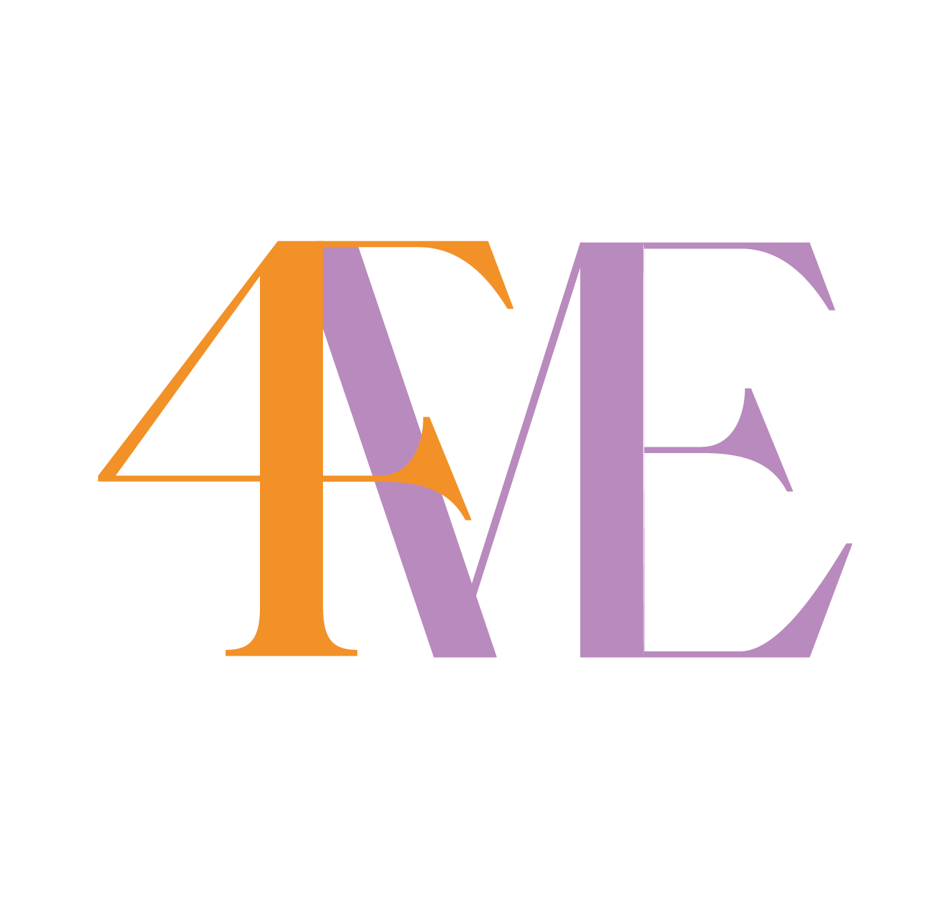

From the feedback and with the new colors I started on version 2 of the prototype.

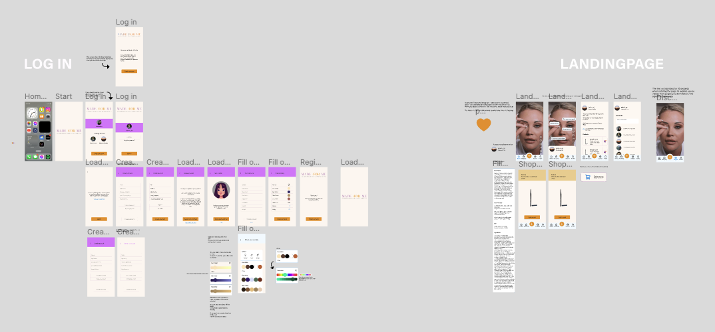

You can check out the prototype here: https://www.figma.com/proto/NuzwEXLk8YnLHqhjcV0c5G/Looks---privat-backup?page-id=2080%3A6241&node-id=2080%3A6276&viewport=1876%2C710%2C0.19&scaling=min-zoom&starting-point-node-id=2080%3A6276&show-proto-sidebar=1

From the first to the second prototype, I started shaving away functions that wasn’t necessary for the applications as well as trying to clean it up. One example is in the shopping part of the application:

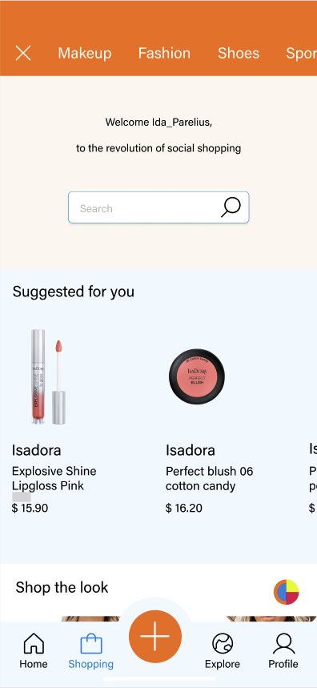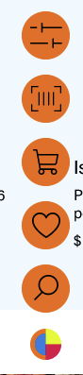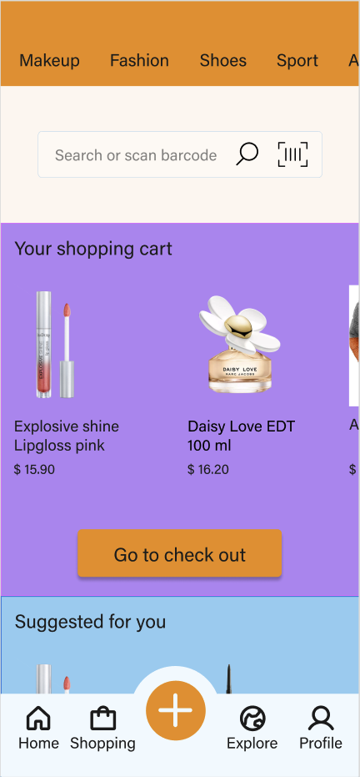

In the first version (on the left) you can see a round object in the bottom right corner. I you press this you get more ikons to choose form. But after the user testing phase I quickly saw that none of the users used it or understood what I was. Therefore, I choose to make the shopping cart more available and keep it on the top of the shopping page. The scan barcode option was put in the search field, and the rest of the icons were eliminated, as the user used other ways to get to these.

When the second prototype was done, I asked the start-up for a meeting to discuss the changes. I had added brighter colors in the new version and heading to make it clear where in the application you are.
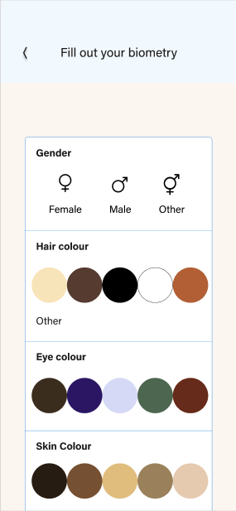

I got great feedback from the group, and they said there were many things they did like, but that the general design of the new version is “blocky and childish”, and they didn’t want as many colors in the app as their target group want.

The final design is pr. 09.02.23 not finished, but the pages I have shown earlier looks now like this:

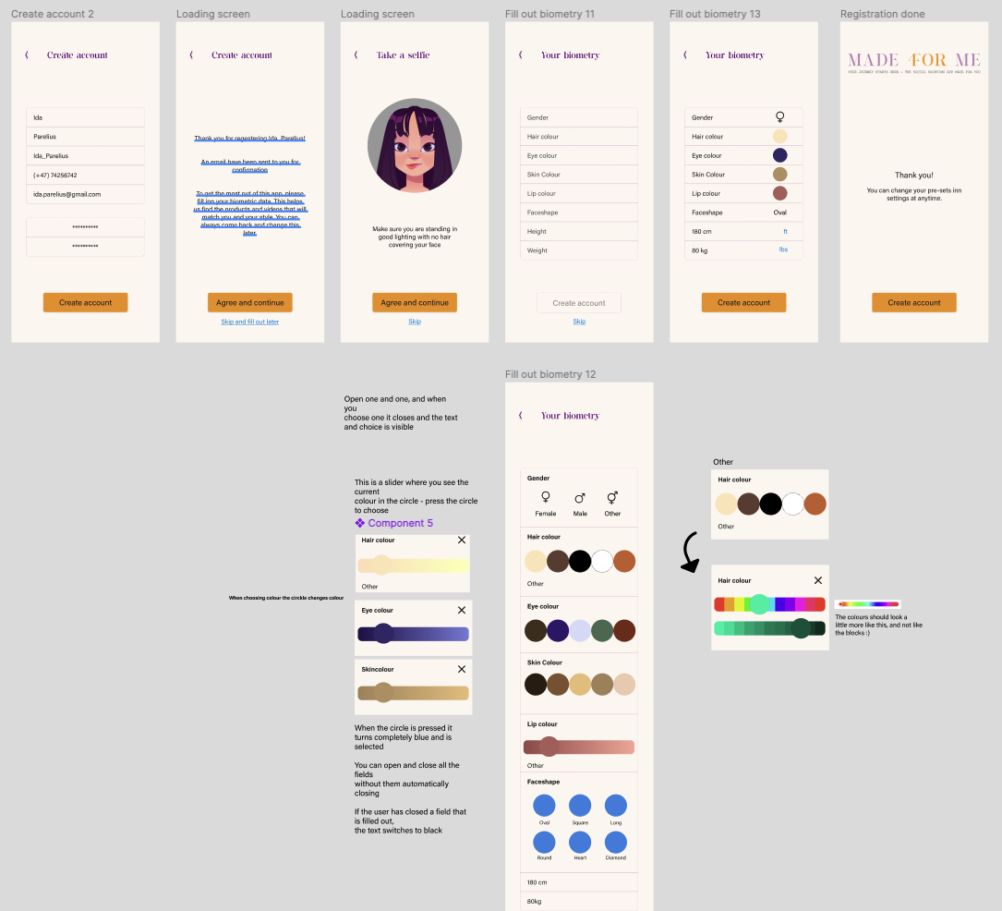
(legg inn alle 3 bilder)

If you are interested in following my process further on, click here for the prototype:
or check out Made 4For Me on Instagram: https://www.instagram.com/madeformeapp/

